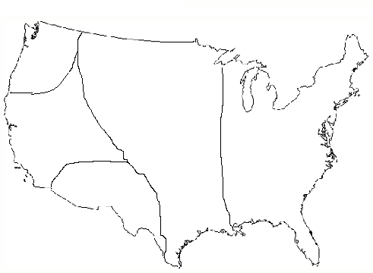
Native American Unit Study Guide
Pacific Northwest (Northwest Coast)

Plains
Eastern Woodlands

Desert Southwest

- Use the map to identify and label each region.
Eastern Woodlands Plains Pacific Northwest Desert Southwest

- What kind of government did the Eastern Woodlands have?
The Eastern Woodlands region had one significant form of government called the Iroquois League. This was made up of the five tribes in the Iroquois nation, and they formed the Great Council. This group felt that they were stronger in numbers, and made group decisions for the region, as well as governed their own individual villages.

- Explain how the Eastern Woodlands culture adapted to their environment.
The Eastern Woodlands tribes adapted to their environment by cutting down some of the many trees and using them to make tools and shelter. In addition, they practiced advanced agricultural techniques such as slash and burn, and using fish as fertilizer.
- How did the Eastern Woodlands adapt their agriculture to thrive in their region?
The Eastern Woodlands tribes adapted their agriculture by using the slash and burn technique to thrive in their region. This technique involved traveling to the center of the forest, carving circles into the bark of several trees, and waiting a year for those trees to die. While they died, their leaves fell to the ground, allowing more sunlight to reach the forest floor and nourish the crops. Finally, they burned down those dead trees, and used the ash in the dirt to fertilize the soil.

- Explain how the Desert Southwest culture adapted to their environment.
The Desert Southwest tribes adapted to their environment by carving their homes into the sides of cliffs to protect from the large amounts of heat and sunlight. In addition, they dug trenches to access the underground springs to irrigate their crops in the dry climate.
- Explain how the Northwest Coast culture adapted to their environment.
The Northwest Coast tribes adapted to their environment by cutting down the large cedar trees to make their homes and the large, dugout canoes they used to travel for trading. They also used these trees to build up their shelters to protect their food and families from predators, snowfall, and flooding.

- Explain how the Plains culture adapted to their environment.
The Plains tribes adapted to their environment by living near rivers and streams to aid in their farming of important crops. In addition, some Plains tribes created homes that were easily portable (tepees) to be able to follow the buffalo herds that provided food, clothing, and tools for the Native Americans.

- What is the Land Bridge theory, and how does it explain the first Americans’ arrival?
The Land Bridge theory says that the first Americans arrived to North America on foot. They did this by following large game across a bridge made of land that connected Asia to Alaska. This land is in the area now referred to as the Bering Strait. As a result, that land bridge is called Beringia. This land bridge is said to have sunk after the ice age melted nearby glaciers, and covered it with vast amounts of water.

