Realistic Fiction | Non-fiction | Fantasy | Historical Fiction | Free Choice | Fantasy | Non-fiction | Mystery
Free Choice | Realistic Fiction | Science Fiction | Adventure | Non-fiction | Science Fiction | Historical Fiction | Free Choice
Mystery | Adventure | Realistic Fiction | Mystery | Free Choice | Fantasy | Mystery | Realistic Fiction
Free Choice | Historical Fiction | Biography | Realistic Fiction | Science Fiction | Biography | Free Choice | Adventure
Non-fiction | Free Choice | Fantasy | Free Choice | Realistic Fiction | Fantasy | Non-fiction | Mystery
40 Book Challenge
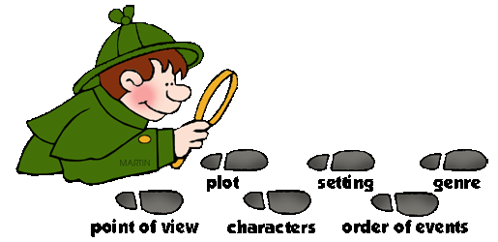
Genre Requirements
Realistic Fiction – 6 Free choice - 8
Historical Fiction – 3 Adventure – 3
Science Fiction – 3 Fantasy – 5
Non-fiction – 5 Biography – 2
Mystery – 5

